Mobile application for AR navigation

Author: Repina Anastasia, MSE2018

Moscow, 2019

Abstract

Every day people navigate from one place to another in order to achieve their tasks and goals. One of the most common types of navigation is on foot. Walking through the streets people do not have to pay for tickets and stack into the traffic jams. According to the Boston Consulting Group and Ipsos research [[1]] people spend half of their life on going somewhere. So, inclusion of an educational or the cultural part to this way can broaden the people’s horizons and help not to get bored while walking. Although, it is the 21 century already, most of the citizens prefer to use paper maps or their online analogs in order to find the exact way. However, this case involves a lot of problems: from dependency on the stable internet connection up to the difficulties connected with understanding is it the right place to turn left of right. The existing applications on the market are devoted mainly to the usual maps and do not pay much attention to the improvement of the navigational process, which can positively influence of the user’s experience. So, that is why trying to make the everyday navigation easier seems a good idea. The only questions is how to do it?

The main purpose of the work is to create a mobile application which helps the user to faster and easier navigate to the destination point as well as stay informed of the nearby excursion places. The augmented reality is one of the options of how this goal can be achieved. Having an augmented reality projection together with a usual map can help to solve the mentioned difficulties, so the user’s experience will become even better. Monitoring the geolocation in a real time using the in-device modules and creation an augmented reality projection together with changes on the common map do not require the expenditure of personal time. In case of any problems the application will signal the user. It stores information about the excursion objects: theaters and museums, so while navigating to the destination location it is possible to learn more about the city where you are now. Furthermore, an opportunity to load the saved and frequently used routes can save time used for searching. The application is implemented using technologies: ARKit, Google Firebase, MKMap and others.

The proposed project is of great importance since it contributes to the improvement of contemporary complex and far from ideal approaches to human navigation. The application is available for download for more all the iOS devices which have the AR module inside on GitHub via the link - <https://github.com/arepina/AR>.

***Index Terms*** *— mobile application, iOS, geolocation, navigation, augmented reality, map.*

Definitions and acronyms

GitHub – the largest web service for hosting IT-projects and their joint development

Firebase – is a mobile and web application development platform developed by Google

Augmented reality (AR) – the result of blending of interactive digital elements together with the real world

Virtual reality (VR) - is an interactive computer-generated experience taking place within a simulated environment

MKMap – framework which if used for setting a map to the application

ARKit – a set of tools for the iOS platform which are used the augmented reality creation

iOS – mobile operating platform

Geolocation – the position coordinates of the object on the Earth

Swift – programming language which is used for the iOS applications development

Splash-screen – an introduction screen inside the application

Walkthrough-screen – a several page screen used for helping with understanding of curtain tasks

ZenHub – independent project management tool natively integrated with GitHub

Contents

Abstract 2

Definitions and acronyms 3

1. Introduction 6

2. Existing solutions 8

Conclusion 8

3. Information model and algorithms 9

3.1. Information model 9

3.2. Navigation algorithm 9

Conclusion 9

4. Requirements 10

4.1. Functional requirements 10

4.2. Reliability and security requirements 10

4.3. Technical and software requirements 10

Conclusion 10

5. Implementation details 11

6. Architecture and design 12

6.1. MVC Description 12

6.2. Design and interface 12

Conclusion 12

7. Technology stack 13

7.1. Development tools 13

7.2. Main libraries 13

7.3. Main third party services 13

7.3.1. ARKit 13

7.3.2. Firebase 13

7.3.3. GitHub 13

7.3.4. MKMap 13

Conclusion 13

8. Usability evaluation 14

9. Conclusion 15

10. References 16

Appendix A. Use case diagram 18

Appendix B. Database scheme 19

Introduction

Over the past few years, the mobile applications market has seen a significant increase in the number of new programs that solve various tasks [[2]]. Now the most familiar things can be done online using a phone or tablet: ordering the food, playing games or just talking with friends and relatives, without wasting time moving from one place to another. This success can be explained by the emergence of new special tools and devices that can be associated with the mobile phones, as well as with the emergence of new features within the gadgets themselves.

Everyday people solve navigation problems trying to find the shortest and fastest way from one place to another. Although, this problems has other aspects, which people do not spot from the first glance. During the way there are a lot of direction changes, so each time user has to check whether is it the right place to turn somewhere, for example. So, the lack of an ordinary map functions as well as the difficulties of the unknown route navigation are also important points of the navigational task. Furthermore, the problem becomes even more complicated when the navigation type is restricted and we choose only ‘on foot’ option. In that case pedestrians walk more freely in the available space, so it is necessary to adapt the route more often. Over the last decade researchers have become developing systems based on the current situation around the user, not the one which was at the start of the route [[3]]. That is why applications for the outdoor navigation for pedestrians is the separate part among the other navigational cases.

According to the Manifest research [[4]] over 77% of smartphone owners regularly use navigation applications. That means that the auditory is very huge and the solution of the problems inside this applications as well as new functionality can improve the user-experience and attract new clients.

In the context of this work, the author will try to do both.

Augmented Reality is now being used by the world leader in GPS navigation technology, allowing a virtual overlay to live cameras in real-time. The majority of the new mobile phones and tablets support the AR function. That is why using the AR inside the pedestrian navigational application sounds as a good idea as the opportunities of the technology will help to solve the ‘wrong turn’ problem as well as help to better understand what is around the user.

**The goal of this work is** thecreation of the mobile IOS application for outdoor AR navigation for pedestrians. The created application will be used for the route-finding purposes. Using this application user will be able to navigate to the destination point from the current location using both usual map and the AR mode. There are no specific restrictions of whom can use the application. However, the person should not have any visual or motor disabilities which can spoil the user experience. Also, it is necessary to have an iOS platform device with an AR module inside.

**In order to achieve the goal several tasks should be done:**

1. Study of the subject area, analysis of existing solutions;
2. Development of application functionality;
3. Selection of technical means of implementation and platform;
4. Development of models and algorithms for data transmission and processing;
5. Study of technical means of implementation and platform;
6. Choose of modules and application architectures;
7. Development of application design;
8. Application development and testing;
9. Development of technical documentation.

In the further chapters, the existing analogues of the AR navigation applications are analyzed, the platform is selected (Chapter 1), the information model and data transmission, as well as the AR navigation algorithms are established (Chapter 2), the chosen libraries and the technology stack, as well as the details of the software implementation are mentioned (Chapter 3). In conclusion, the main results of the work are presented and the ways of its continuation are considered. The Appendices to the work contain the data base schema and the use case diagram.

1. Existing solutions

In this chapter the AR market and existing analogues of applications for navigation are analyzed, the platform is selected.

* 1. Applications for AR navigation market

According to the DigiCapital ‘Augmented/Virtual Reality Report and Database Q1 2018’[[5]]report, AR could approach $3,5 billion installed base and $120 billion revenue within 5 years. At the same time, VR might deliver $50 million installed base and $30 billion revenue (pic. 1).

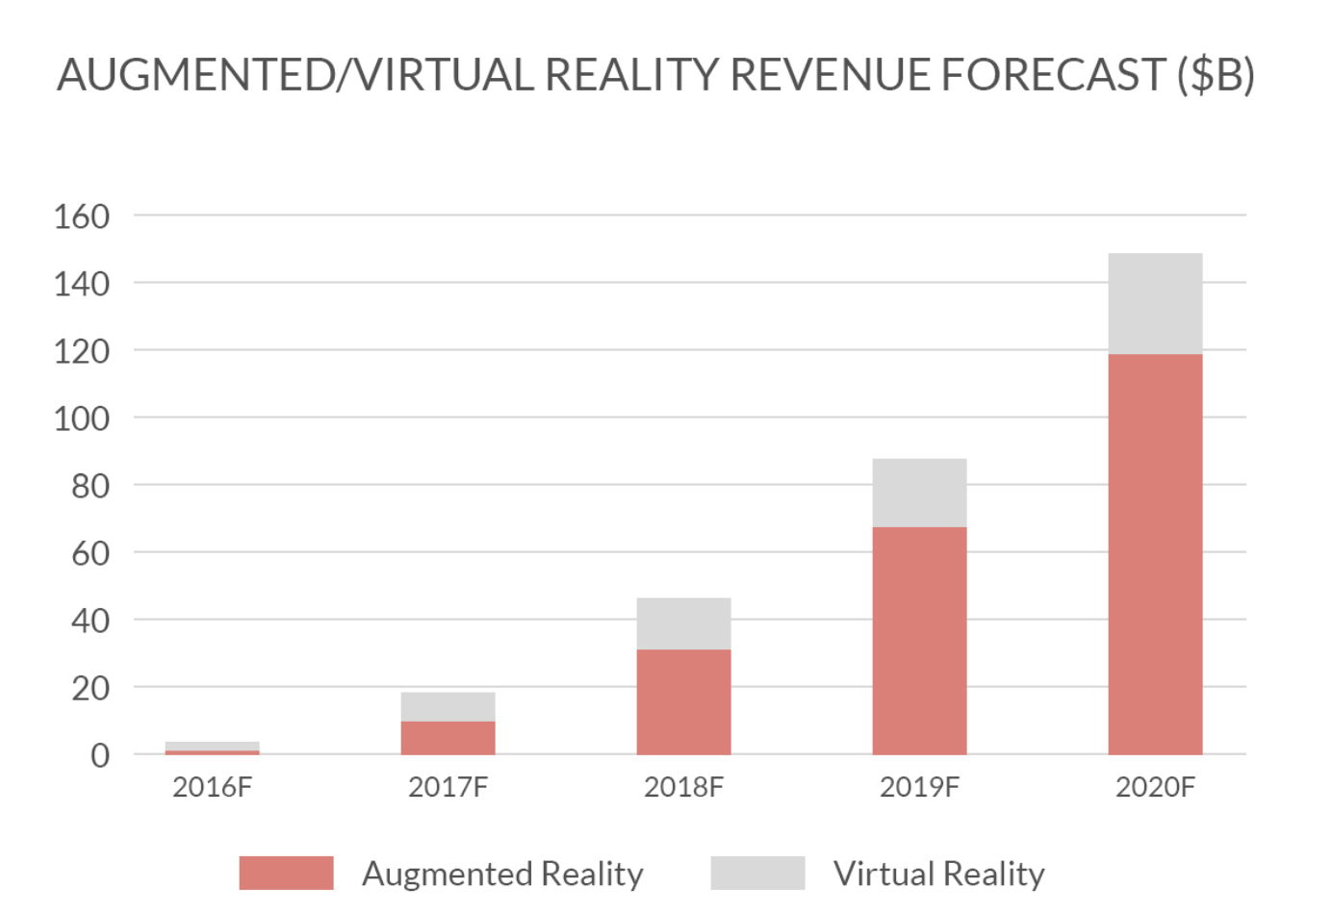

Picture 1. AR/VR Platform Revenue

That is a pretty big difference, and it all has to do with AR’s ubiquity and VR’s focus. The main reason for that might be connected with the VR’s lower mobility and exclusive immersion focuses it on entertainment use cases and revenue streams whereas the AR applications try to cover all the market. Furthermore, the navigation AR applications category is the 4th largest among all the possible markets (pic. 2).

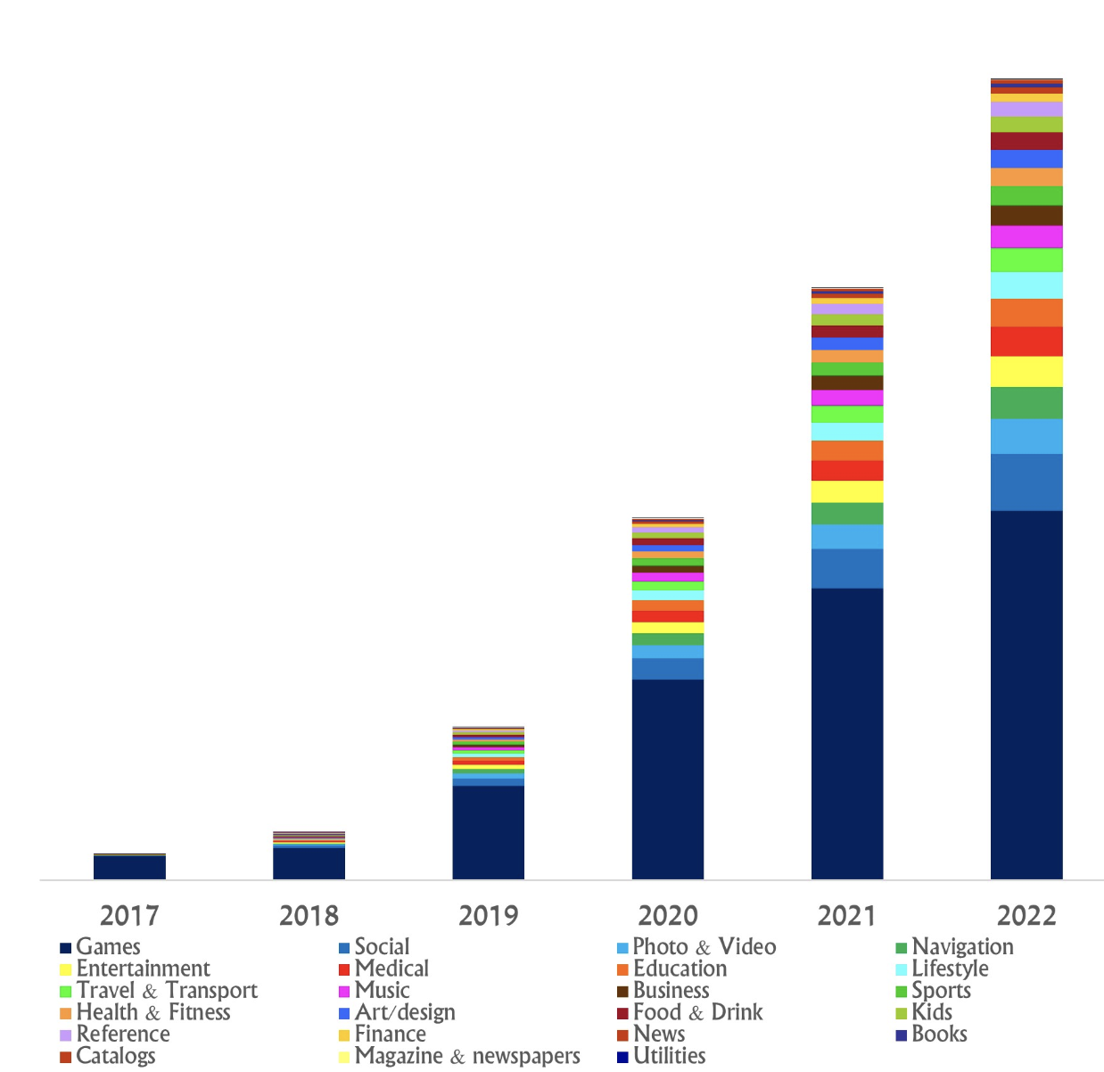

Picture 2. AR categories popularity

It inferiors in popularity to the utilities, art and social categories only. Although, the revenue numbers in the navigation AR applications category are the highest (pic. 3). So, the opportunities of the development the application for the navigation using augmented reality are huge enough.

As indicated by another report from Tractica [[6]], the expanding use cases for mobile AR will lead to growth from 342.8 million unique monthly active users (MAUs) globally in 2016 to nearly 1.9 billion MAUs by 2022.

Obviously, the AR is a bit rough yet and still in its early stages. Nevertheless, taking the above numbers into consideration, it is possible to predict the AR’s quick advancement and development on account of some key drivers as an expanding number of telephones and tablets and their all-encompassing usefulness or the expanding Internet speed.

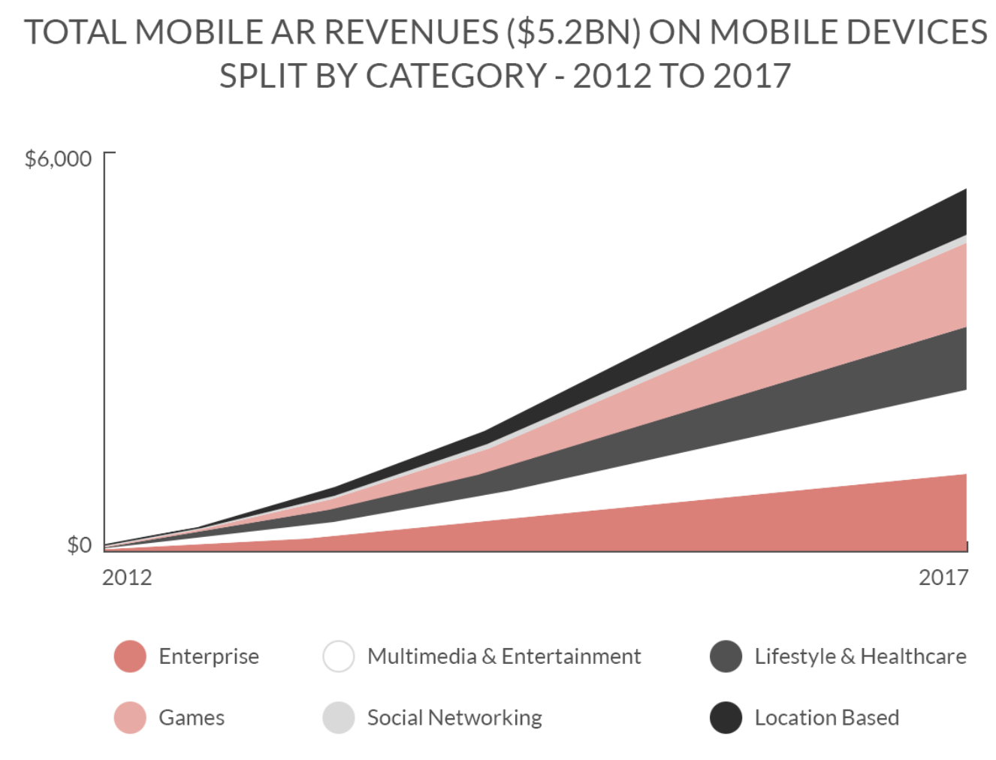

Picture 3. AR revenues split by categories

* 1. Existing solutions overview

As part of the research work, the preparatory stage is very important. At this stage, it is necessary to analyze existing projects and understand what their benefits and drawbacks are. Thus, it will later be possible to create your own work, taking into account the problems and advantages of the competitors.

The corresponding review within the framework of the work was carried out not only for the IOS platform, but also for the Android one with the aim of a more extensive study of the area. In each application, five parameters were evaluated: price, AR mode existence, stability of work, availability of a favorite places mode and search module (Table 1).

Table 1

Analogues table

|  | **Price** | **AR mode** | **Map mode** | **Stability** | **Favorite places** | **Search** |
| --- | --- | --- | --- | --- | --- | --- |
| Yandex Maps | free | + | + | +/- | + | + |
| Google Maps | free | + | + | + | +/- | + |
| Apple Maps | free | - | + | + | + | + |
| Welc map | free | +/- | + | - | - | - |
| Eye maps | $4.99 | - | - | + | - | + |
| Wikitude | free | +/- | - | + | + | +/- |
| AR Maps | free | +/- | + | - | + | + |
| Mosgorpass | free | + | + | +/- | + | + |
| ARCity | free | + | + | +/- | - | + |
| My application | free | + | + | + | + | + |

“Yandex Maps” [[7]] – search and information map service by Yandex created for both iOS and Android operating platforms, which helps to find all the necessary addresses, streets, get directions and make plans for the trips and travels. The application also provides functionality to store favorite places in the city. The beta version of the application with the AR mode is not stable yet as it is possible to catch an exception during the usage (pic. 4).

“Google Maps” [[8]] – a set of applications built on the basis of a paid map service and technology provided by Google. The application has a well-working AR mode which can be easily combined with the usual map. So, the user can choose which mode to use or use both. However, the search mode does not provide enough functionality to work with favorite places, so this is one of the points to the future improvements of the applications (pic. 5).

|  |  |
| --- | --- |
| https://www.iphones.ru/wp-content/uploads/2017/09/ar_ya6.jpg | https://heise.cloudimg.io/bound/1920x1920/q90.png-lossy-90.webp-lossy-90.foil1/_www-heise-de_/imgs/18/2/4/2/3/0/5/8/2018-05-08__199_-d575b373258a39c5.png |
| Picture 4. IOS application “Yandex Maps” | Picture 5. IOS application “Google Maps” |

“Apple Maps” [[9]] – Apple's mapping service for iOS and MacOS operating systems, the intellectual functions of which will help to easily find the right place and quickly get to it. The application is built into the both mobile and desktop versions. However, it does not have an AR mode yet, although the ARKit framework is highly popular and is promoted by the Apple company (pic. 6).

“Welc map” [[10]] – is an Android and iOS application created by SPAM company, which provides information about the excursion places nearby using the AR mode. However, every function inside the application have problems with stability and regularly throw exceptions. Also, the search engine helps to find only the places which were added by the developers to the list, although it might be necessary to look for other places nearby. Furthermore, it is impossible to save the favorite AR places to visit them later, for example (pic. 7).

|  |  |
| --- | --- |
| https://www.tabletowo.pl/wp-content/uploads/2018/07/nowe-Mapy-iOS-Apple-1115x900.jpg | http://augmentyourjourney.altervista.org/wp-content/uploads/2018/01/11-1.jpg |
| Picture 6. IOS application “Apple Maps” | Picture 7. IOS application “Welc map” |

“Eye maps” [[11]] – an iOS and Android application created by Kostas Gaitanis, which provides a 3D map of the world displaying instantly what you see. It is possible to look for the any place of the Earth and see what is located nearby, but not in the AR. Also, the application is not free to use and requires 4,99$ payment for an access (pic. 8).

“Wikitude” [[12]] – an all platforms application created by Wikitude GmbH which has a broad range of functions for excursions. The AR mode was added in one of the latest releases, however it is not working properly yet. Furthermore, the search engine has some logic mistakes in the code, so it can show the wrong places (pic. 9).

|  |  |
| --- | --- |
|  | https://www.poderpda.com/wp-content/uploads/2012/05/wikitude-android-e1337655320576.jpg |
| Picture 8. IOS application “Eye maps” | Picture 9. IOS application “Wikitude” |

“AR Map” [[13]] – an iOS application created by Chirag Leuva. It provides functionality to navigate from one place to another using the map or AR mode. Also, it has functionality of favorite places and a good search solution. However, the stability of the work is the main problem of the application (pic. 10).

“Mosgorpass” [[14]] – an iOS application create by the Mosgortrans. It allows real-time monitoring of the movement of ground-based urban passenger transport in Moscow and provides up-to-date information on schedules, arrival time of the desired bus, tram or trolleybus to a stop and estimated time of arrival at its destination using the AR mode. However, the stability of the applications is the same problem as in the previous application (pic. 11).

|  |  |
| --- | --- |
|  |  |
| Picture 10. IOS application “AR Map” | Picture 11. IOS application “Mosgorpass” |

“ARCity” [[15]] – an iOS application created by Blippar. It provides one of the best AR mode from the examined applications. Although, it is possible to search for any place in the city, the user can not add them to the favorite places list (pic. 12).

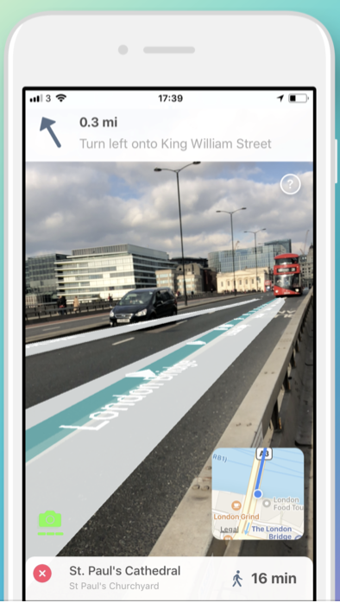

Picture 12. IOS application “ARCity”

As can be seen from the table. 1, the mobile application that will be created as a result of this work will have an advantage over the main competitors, since they have limited functionality and problems with work stability and the AR mode. Economic and financial issues are not considered in the work. The application will be distributed free of charge. None of the studied applications solves all problems, which indicates that the problem exists, and it can be solved by combining the successful ideas and approaches in a single project.

The developed mobile application will be created for the IOS operating system. According to IDC Quarterly Mobile Phone Tracker [[16]], companies sold a total of 344.3 million smartphones worldwide in the first quarter of 2017 (1Q17). The share of iOS in the smartphone market continues to occupy about 32% of the global volume. Furthermore, the iOS platform has an ARKit framework which let the developers easily create the applications with the augmented reality. That is why this platform was chosen for the application.

Conclusion

The chapter reviewed and analyzed the existing applications in the market. Development platform was selected.

1. Information model and algorithms

The chapter describes the developed information model and the navigation algorithm.

* 1. Information model

To store the accumulated information the database creation was selected. It was decided to use a relational No-SQL database. A data model was developed in the third normal form, in which many-to-many links are not used. The database consists of 11 tables, described in Table. 2

Table 2

Database

| **Название сущности** | **Поля** | **Описание** |
| --- | --- | --- |
| Routes | string : key  string : coordinates  string : place | Сохраненные маршруты |

All the table links are presented on the pic. 12

Picture 12. Table links

For each table in the application, there is an analogue that is associated with the storage using the Firebase API, which will be further discribed in Chapter 3. Keys that link data in the tables are generated by the Firebase service automatically and during the creation of a new record in one of the tables, the correct key is placed.

* 1. Navigation algorithm

The geolocation module of the phone is the main source of data inside the application. So, the navigation algorithm uses exactly the coordinates which are tracked by this module with no intermediary layers. The ….

The ARKit is ….

In order to make the coordinates usage possible it is necessary to let the application connect to the geolocation module. The request will be made during the first entrance to the application (pic. ).

Picture

The same situation applies to the ARKit. It also needs a permission to use the camera of the phone (pic. ).

Picture

After all the permissions are granted is it possible to use all the functions of the application. In order to track the current users passion the listener is created. Each second it updates the coordinates via a special request directly to the geolocation module.

The main application algorithm is divided into several steps. Each of them is responsible for their own mathematical calculations.

During the development process several technologies were used. First of all, it is the ARKit itself. None of the augmented reality applications for the iOS can be done without this framework. For the navigational purpose CoreLocation framework was chosen as the most frequently used one.

Together with the iOS 11 release the Apple company has unleashed the power of ARKit onto the iOS development community.

Before going into details it is necessary to mention that there are two types if steps: main and intermediary. Main steps are those in which the pedestrian will change the direction, for example, turn left or right. Each pair of the main steps is connected with a set of intermediary steps, so it is possible to easily navigate from one main point to another. The calculation of the main points is given to the integral maps API, created by the iOS map application developers. In order to find these steps the developer needs to pass the start and finish coordinates as well as the type of transport which is supposed to be used. In our case, this type is named ‘walking’. Although, it is possible to see the main routes for a ‘car’ type route.

//todo add code here

After that steps is finished we move to the calculation of the intermediary points. For that purpose there is a special algorithm.

//todo add code here

After all the preparation steps are done it is necessary to pass to the method the geological coordinates of the start and finish points, and get the AR nodes for each of the route steps.

//todo add code here

So, now we have a set of the AR nodes. However, it is also important to mention, how the AR node is created itself. For the visualization purposes the bean form was chosen for each of the nodes.

//todo give an example of AR node class

Conclusion

1. Requirements
   1. Functional requirements

The application should provide functionality to perform the following tasks:

1. Create an account from the sign in screen
2. Log into the existing account from the sign in screen
3. Log out of the account from the settings screen
4. Find the destination place using the search line from the main screen
5. Set the destination point by the map tap from the main screen
6. Set the destination point by the search line from the main screen
7. Navigate to the destination point using the map from the main screen
8. Navigate to the destination point using the AR mode from the main screen
9. Combine the map and AR modes for navigation from the main screen
10. Add and remove the current location and the destination place to the “favorite places” list from the main screen
11. Load the location from the “favorite list” and set it as the destination point from the “favorite places” screen
12. See the number of meters and the time up to the finish point from the main screen
13. Send a request to the AR mode, location and the camera of the phone from the main screen
14. Send an email to the developer from the settings screen
15. See the application information from the information screen
16. See the walkthrough of all the necessary request changes from the settings screen
17. Load the theaters objects from the main screen
18. Load the museums objects from the main screen
19. Move the map to the current location by button tap from the main screen
20. Close the current route from the main screen
    1. Interface requirements

Below screen layouts are presented that are planned to be changed during the development process.

|  |  |
| --- | --- |
|  |  |
|  |  |
|  |  |
|  |  |
|  |  |
|  |  |
|  |  |
|  |  |

* 1. Input and output format requirements

Input data - user clicks on the screen.

Output - change the image on the screen.

* 1. Reliability and security requirements

Usage of the mobile application should not lead to the unhandled exceptions and shutting down of the application with an error.

* 1. Terms of Use

The end user of the program (operator) must have practical skills in working with the graphical user interface of the iOS operating system.

* 1. Requirements for the composition and parameters of technical equipment

1. Device based on iOS version 4.4 and above;
2. Availability of internet connection;
3. Availability of SD card;
4. The presence of the installed Google Fit application of the latest version on the device.
   1. Requirements for information and software compatibility

Software:

1. Android operating system version 4.4 and higher;

2. The Google Fit app is the latest version.

Allowed to use in the development of the following software:

1. Google Fit History API, Recording API, Sensors API, Sessions API;

2. Firebase API;

3. Google Play Services API;

4. Library SlidingIntroScreen;

5. MPAndroidChart library.

* 1. Marking and Packaging Requirements

It is possible to download and install the application from the GitHub by a user who has the required hardware.

* 1. Requirements for transportation and storage

Requirements for transportation and storage of the application are not presented.

* 1. Special requirements

There are no special requirements for the application.

Conclusion

1. Implementation details

<https://apptractor.ru/info/articles/pochemu-arkit-luchshe-alternativ.html>

1. Architecture and design
   1. MVC Description
   2. Design and interface

Conclusion

1. Technology stack
   1. Development tools
   2. Main libraries
   3. Main third party services
      1. ARKit
      2. Firebase
      3. GitHub
      4. MKMap

Conclusion

1. Usability evaluation
2. Conclusion
3. References
4. Mata Rivera Miguel, Claramunt Christophe, Juarez Alberto. An experimental virtual museum based on augmented reality and navigation, 497-500, 10.1145/2093973.2094058, 2011;
5. Narzt Wolfgang, Pomberger Gustav, Ferscha Alois, Kolb Dieter, Maјller Reiner, Wieghardt Jan, Hartner Horst, Lindinger Christopher. Augmented reality navigation systems. Universal Access in the Information Society, 4, 177-187, 10.1007/s10209-005-0017-5, 2006;
6. Reitmayr Gerhard, Schmalstieg Dieter. Collaborative augmented reality for outdoor navigation and information browsing, Proceedings of the Symposium on Location Based Services and TeleCartography, 2004;
7. Raskar Ramesh, Low Kok-Lim. Interacting with Spatially Augmented Reality, ACM International Conference on Computer Graphics, Virtual Reality and Visualisation in Africa, 10.1145/513867.513889, 2001;
8. Alessandro Mulloni , Hartmut Seichter , Dieter Schmalstieg. User experiences with augmented reality aided navigation on phones, Mixed and Augmented Reality (ISMAR), 2011;
9. Kyle Roche. Pro iOS 5 Augmented Reality, 345, APRESS, 2011;
10. Randall Shumaker Stephanie Lackey (Eds.). Virtual, Augmented and Mixed Reality. Applications of Virtual and Augmented Reality, 6th International Conference, VAMR 2014 Held as Part of HCI International 2014 Heraklion, Crete, Greece, June 22–27, 2014, Proceedings, Part II;
11. Swift developer blog, “Pass Information Back to the Previous View Controller” [Electronic resource]. URL: https://swiftdeveloperblog.com/pass-information-back-to-the-previous-view-controller/ (request date: 03.01.2019);
12. GitHub, Side Menu for IOS library site [Electronic resource]. URL: https://github.com/jonkykong/SideMenu (request date: 05.01.2019);
13. Apple Inc., ARKit [Electronic resource]. URL: https://developer.apple.com/arkit/ (request date: 05.01.2019);
14. Figma, Online UI design tool [Electronic resource]. URL: https://www.figma.com/ (request date: 04.12.2018);
15. LongList, IOS Popup View Using Separate View Controller [Electronic resource]. URL: http://longlist.org/ios+popup+view+using+separate+view+controller++xcode+8++swift+3 (request date: 05.01.2019);
16. Сайт Ray Wenderlich, Augmented Reality and ARKit Tutorial [Electronic resource]. URL: https://www.raywenderlich.com/378-augmented-reality-and-arkit-tutorial (request date: 09.02.2019);
17. Collective Idea, ARKit Wall and Plane Detection for iOS 11.3[Electronic resource]. URL: https://collectiveidea.com/blog/archives/2018/04/30/part-1-arkit-wall-and-plane-detection-for-ios-11.3 (request date: 05.01.2019);
18. Medium, ARKit and CoreLocation [Electronic resource]. URL: https://medium.com/journey-of-one-thousand-apps/arkit-and-corelocation-part-one-fc7cb2fa0150 (request date: 20.01.2019);
19. YouTube, GPS search [Electronic resource]. URL: https://www.youtube.com/watch?v=8-TDf_7j59Y (request date: 05.01.2019);
20. GitHub, Swift Spinner for IOS library site [Electronic resource]. URL: https://github.com/icanzilb/SwiftSpinner (request date: 07.02.2019);
21. GitHub, Swift Auto Diagram for IOS tool site [Electronic resource]. URL: https://github.com/yoshimkd/swift-auto-diagram (request date: 17.01.2019);
22. Rochester Institute of Technology, Introduction to Augmented Reality [Electronic resource]. URL: http://www.se.rit.edu/~jrv/research/ar/introduction.html (request date: 23.01.2019);
23. Academia.edu, Scientific platform [Electronic resource]. URL: https://www.academia.edu/ (request date: 12.01.2019);
24. ZenHub extension for GitHub[Electronic resource]. URL: https://www.zenhub.com/ (request date: 21.11.2018);
25. GitHub Inc., Hosting service for version control using Git [Electronic resource]. URL: https://github.com/ (request date: 21.11.2018);
26. YouTube, Walkthrough screens creation [Electronic resource]. URL: https://www.youtube.com/watch?time_continue=73&v=1F_HVMHocdA (request date: 21.11.2018);
27. Movable Type, Calculate distance, bearing and more between Latitude/Longitude points [Electronic resource]. URL: http://www.movable-type.co.uk/scripts/latlong.html (request date: 10.12.2018);
28. SwiftBook, Marshrutisation with MapKit and Core Location [Electronic resource]. URL: https://swiftbook.ru/post/tutorials/marshrutizaciya-s-mapkit-i-core-location/ (request date: 07.12.2018);
29. HackerNoon, Building a location app with ARKit, CoreLocation and Pusher [Electronic resource]. URL: https://hackernoon.com/building-a-location-app-with-arkit-corelocation-and-pusher-bee44fdec44f (request date: 05.02.2019);
30. Russia Open Data [Electronic resource]. URL: https://data.gov.ru/ (request date: 25.01.2019).

Appendix A. Use case diagram

Appendix B. Database scheme

1. <https://www.ipsos.com/sites/default/files/2017-06/Ipsos_Update_June_2017.pdf>
2. <https://www.knowband.com/blog/mobile-app/growth-of-mobile-app-market/>
3. Gartner G, Cartwright W, Peterson MP (2007) Location Based Services and Telecartography. Springer-Verlag, Berlin Heidelberg
4. <https://themanifest.com/app-development/popularity-google-maps-trends-navigation-apps-2018>
5. <https://www.digi-capital.com/reports/#augmented-virtual-reality>
6. <https://www.tractica.com/research/mobile-augmented-reality/>
7. <https://itunes.apple.com/ru/app/yandex-maps/id313877526?mt=8&ign-mpt=uo%3D4>
8. <https://itunes.apple.com/us/app/google-maps-transit-food/id585027354?mt=8>
9. <https://www.apple.com/ios/maps/>
10. <https://itunes.apple.com/ru/app/welc-map/id1099176799>
11. <https://itunes.apple.com/us/app/eyemaps/id1127920895?mt=8>
12. <https://itunes.apple.com/us/app/wikitude/id329731243?mt=8>
13. <https://itunes.apple.com/ru/app/ar-map/id1248166351>
14. <https://itunes.apple.com/ru/app/мосгорпасс-автобусы-и-метро/id1227002793?mt=8>
15. <https://itunes.apple.com/us/app/arcity-ar-navigation/id1282527727?mt=8>
16. https://www.idc.com/tracker/showproductinfo.jsp?prod_id=37